**Mphys lab book**

**Sem 1 project: IAGOS flight dust**

**Tuesday 06/10/2020**

Sent email to Gary and Martin to introduce ourselves for mphys project

**Wednesday 07/10/2020**

Tasks:

1. Read up on Beswick et al. that describes bcp backscatter cloud probe



- It only detects particles greater than 5 microns but less than 75 microns

2. Read up on Petzold et al. that combines bcp and water vapour data to look at presence and characteristics of high altitude ice clouds



3. register on IAGOS data portal!!!

<https://www.iagos.org/>

information on iagos data sets:

<http://www.iagos-data.fr/portal.html>

4. read up on previous mphys report



**Zoom meeting at Friday 3pm 09/10/2020**

https://zoom.us/j/95346142817

**Friday 09/10/2020**

Zoom meeting with project supervisors – introduced project and ourselves + ideas to do with project

Meeting notes:

-do literature review

-understand how bcp probe works

-research about dust events

**Friday 16/10/2020**

Next zoom meeting Friday 3pm 23/10/2020

**Wednesday 21/10/2020**

Paper providing background on vertical structure of dust in atmosphere following dust events



Papers from merren:

Three papers that discuss characteristics of deposited dust in Doha and one in Kuwait City



Can maybe discuss mineralogy with merren and properties

**Friday 23/10/2020**

Zoom meeting:

<https://zoom.us/j/502489451>

meeting notes:

Download BCP data in NASAames format

* Time
* Longitude and latitude
* Altitude
* Particle concentration
* Tail number

-Time is in seconds from midnight!

-Cloud presence = -9999 means the probe is not turned on

-Equipment not turned on till ~ 300m

-From tail number – can tell rolls Royce engine and retrieve performance data

-Can compare data of different clouds and engine performance/ health

-identify cities and profiles

-make histogram frequency vs time of year (max exposure vs min exposure?)

-focus analysis below ~5km peak

-peak ingestion rate can be dependent on day/dust storm

-ideally has dust event in file -> collect data from 2017-2018 of about 50-100 profiles

-focus on cloud particle data -> to confirm cloud or not check relative humidity

- how frequent, month/year, country/region -> pick out example and use hysplit, location, time -> give air mass, plane altitude

-focus middle east + north Africa -> can extend to SE asia and china

-maybe NE America, Canada (Vancouver)

-interesting comparison (mineralogy)-> merren looks into minerals?

**-Can make time history of dust events over region! -> for region**

- Identify curious flights

**-Demonstrate how our report can be used for future**

Email:

1. Collect as many ascent/descent profiles as possible starting 2018 and work backwards. Say 50-100.
2. Plot all the ascent/descent concentrations on a single graph! Colour code by city.
3. Plot a time series of "dust" event flag versus time, to see the annual change. Colour code by city.
4. Do the same as 3 but colour code by aircraft tail number (for Merren).
5. Take the plot in 2 and average up the particle concentrations over different height intervals - say 300-400m, 400-500m etc. Plot the average concentrations for the whole year (for dust events) as a function of altitude along with the median, standard deviations etc.
6. If there is sufficient data do the same as in 5 but for different parts of the year - you may have to split the year into 3 monthly periods - find out when the dust event frequency is supposed to be highest at what time of year to help with this. This will allow you to compare extreme dust events with average inside and outside the seasonal dust periods.
7. Then start to compare the altitude vs concentration plots for the different cities and then possibly the different aircraft (tail numbers).
8. Keep adding data from as far back as you can say back to 2010-12.There may be year to year variations which is also important to try and cover.
9. Then we can talk about more detailed analysis for specific events/cities which folds into Merren's project. This will allow you to look at average exposures to dust by aircraft in different cities.
10. Then suggest you go to the NOAA HYSPLIT web site:<https://www.ready.noaa.gov/READYVolcAsh.php>
11. You can run HYSPLIT online or download to your computer (PC or Mac). There is a basic tutorial here: <https://www.ready.noaa.gov/documents/Tutorial/html/index.html>
12. Note you can find a description of the HYSPLIT model here: <https://www.arl.noaa.gov/hysplit/hysplit/>HYPLSIT is not a simple gaussian plume model - that is considered passe these days! - it is a hybrid of the "Lagrangian approach, using a moving frame of reference for the advection and diffusion calculations as the trajectories or air parcels move from their initial location, and the Eulerian methodology, which uses a fixed three-dimensional grid as a frame of reference to compute pollutant air concentrations" (The model name, no longer meant as an acronym, originally reflected this hybrid computational approach).
13. One of the HYSPLIT versions contains an automated source-receptor matrix computation which if you complete the above work in time you might have a go at so as to identify the sources of some of the larger dust events. It has been used to look at wind blown dust events in the scientific literature cited on their site e.g. summarised in this paper:

[**https://doi.org/10.1175/BAMS-D-14-00110.1**](https://doi.org/10.1175/BAMS-D-14-00110.1)



**Saturday 24/10/2020**

-Started downloading all data points

**Tuesday 27/10/2020**

Started working on dust codeing

**Wednesday 28/10/2020**

Sent email:

- asking about cloud p1 val and cloud p1 stat

-which altitude to use, barometric altitude, radar altitude or GPS altitude

-aircraft tail number?

Reply:

-Identify dust events manually based on location, altitude and concentration.

-You can find a complete description of the data file format at:

<http://iagos-data.fr/#DataFormatPlace:>

For example line 7 in the data file (NASA AMES) should be

* The file reference date indicates the start point of the time axis in the file. The time axis is always stated in days and begins at 00 UTC on the file reference date.
* For better data management the file reference data will always be the date of the start of the IAGOS project.
* The revision date is the date when the file was created or last updated.
* Both dates are space separated, and stated in the format YYYY MM DD.

The  file number includes the departure time e.g. departureUTC_time: 2011-12-23T11:45:20 for the example file below

Aircraft Identification:

 For example: Data file for

**Flight name :**2011122311452003

**Departure airport :**Frankfurt (FRA)

**Departure date :**2011-12-23 11:45:20

**Arrival airport :**Addis Ababa (ADD)

**Arrival date :**2011-12-23 17:56:20

 The downloaded file contains the line (4)

 "Instrument-03, IAGOS-01, A340-313, D-AIGT, Lufthansa, 4 seconds resolution"

A340-313 (This should be aircraft type and model), D-AIGT is the plane registration number. This is in two parts. The D is the country of origin, i.e. the nationality, in this case "D" refers to Germany. There then follows a suffix containing 1 to 5 characters which refers to the specific aircraft - linking this to a registration number ..Gary may be able to help with this.

The BCP data is reported as the sum of all particles counted over a **4 second period** converted to per cm-3.

**Remembe**r -  the time resolution is 4 seconds, which corresponds to a horizontal resolution of approx 1 km and a vertical resolution of approx 20 m. The full files include ascent, descent and cruise phases.

The **cloud_P1_err** is the standard error based on all the counts over this period, again in per cm-3.

The Val and Stat flag are two different flags. The status flag is the condition of the instrument.

If these two numbers are not -9999 the cloud_P1 coulumn data cm-3 is good to use. Focus on that column for now.

**cloud_P1,** number_concentration_of_cloud_liquid_water_particles_in_air,**no cm-3**, Measured by IAGOS BCP

**cloud_P1_err,** number_concentration_of_cloud_liquid_water_particles_in_air standard_error, no cm-3, Measured by IAGOS BCP

cloud_P1_val, number_concentration_of_cloud_liquid_water_particles_in_air status_flag, 1, Measured by IAGOS BCP

cloud_P1_stat, number_concentration_of_cloud_liquid_water_particles_in_air status_flag, 1, Measured by IAGOS BCP

USE PRESSURE ALTITUDE i.e. barometric altitude

**Saturday 31/10/2020**

**-**code to extract data from nasa ames files

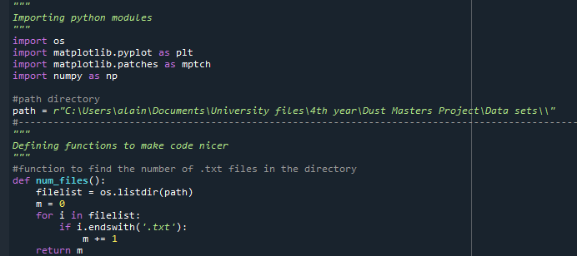

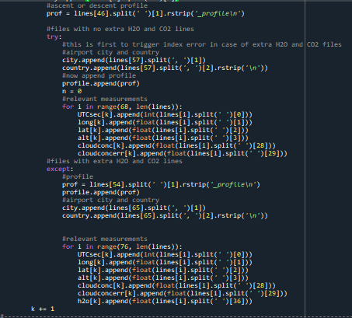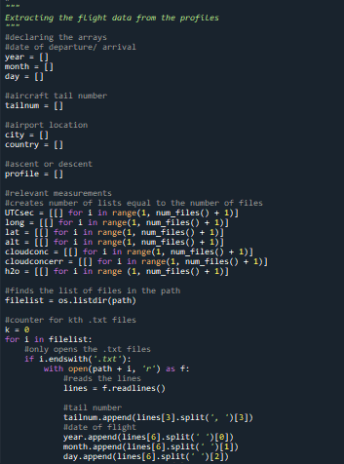

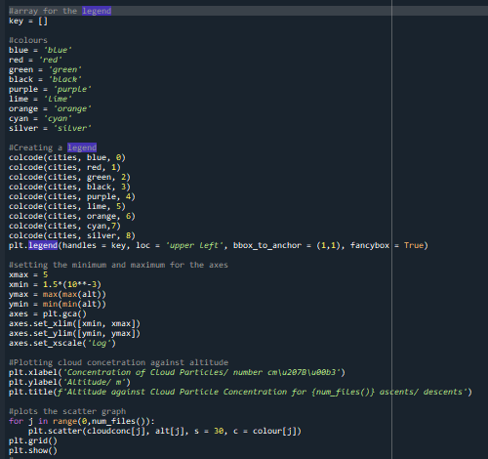

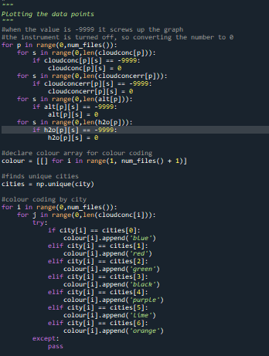

-aiman will do dust frequency graphs!

**Wednesday 04/11/2020**

Sent email:

-Asking about next meeting

-lack of ascent/ descent profiles for latter part of 2016, very few in 2017 and none in 2018

-only two tail numbers found

**Friday 06/11/2020**

Zoom meeting: 2pm

[**https://zoom.us/j/99525618632**](https://zoom.us/j/99525618632)

meeting notes:

-look at linked paper



-keep data in context

-get a map and check RH to see if dust particles or cloud particles-> high RH means cloud, low RH likely dust

-first graph I made might have clouds -> check RH

**Looking at >5micron size particles**

* Check if avg per altitude is equally ascent/ descent
* Log x axis

**4 seconds time resolution**

* Break down avg graph by area and time
* Not 0 value profiles

At ending can:

-note key dust events -> determine particle size with gary?

Period of interest: doha paper on solar panel -> shows monthly variation

Compare with our data!

-make short objective list

Email:

 Action: Produce a list of objectives based on today's discussion and circulate them for feedback.

 Attached is the publication I showed - in case you could not download it from Zoom.

 My main takeaway is

 1. Check the dust event data using RH data as discussed.

 2. Look at regional variation of dust events if possible - you may have to extend the data period you are looking at.

 3. Check the data for the latter half of the year - cf the regional/seasonal dust event frequency based on ground based observations in the attached paper.

 4. Check Merren's paper and accumulate the total particle number over the different ascent/descent phases - the total accumulated particle counts is important obviously for the engine ingestion issue.

 5. End objective - identify a goo Dohar dust event for comparison with surface samples- Merren to provide typical season/air mass source region to correlate better and Gary to "perhaps" provide mean particle size distributions.

**Monday 09/11/2020**

Sent email checking obj:

1. Collate more profiles from 2016 - 2018 to analyse seasonal variation noting 0-value profiles, referencing the attached paper
2. Extend this to pre-2016
3. Note key Doha dust event referencing ground sample paper on solar panels
4. Check RH data to verify cloud/dust content
5. Fix axis of the avg conc vs altitude graph - y-axis and log the x-axis
6. Use Merren's paper to work out the total particle number over different profiles.

**Thursday 19/11/2020**

-cant find relative humidity RH

Emailed asking where to find RH

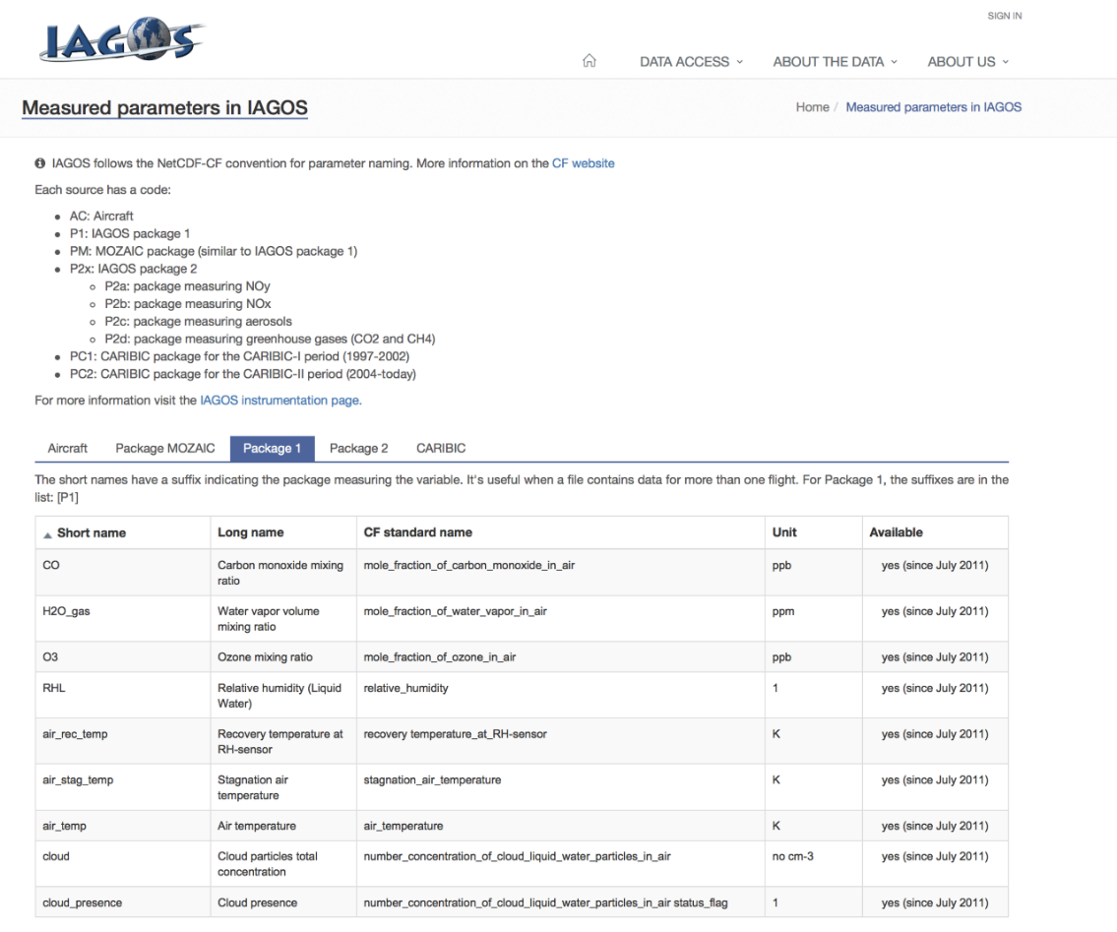Reply:

-H2O gas data!

Water vapour mixing ratio is the density of water vapour divided by the density of dry air without water vapour

e.g. see this explanation if you are unfamiliar with the terms - <https://www.e-education.psu.edu/meteo300/node/519>



**Sunday 22/11/2020**

-cloud concentration averaged over 100 m intervals code

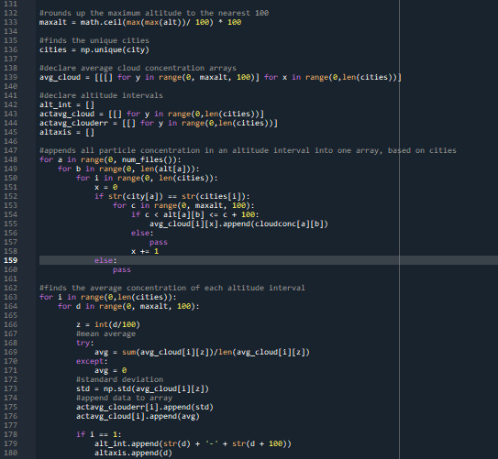

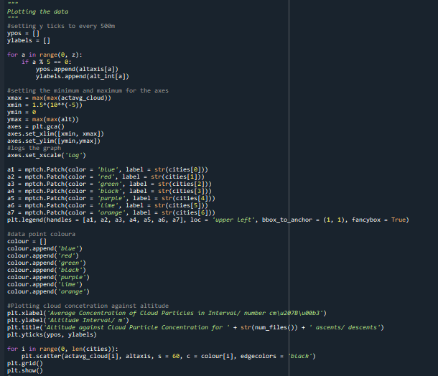

**Friday 04/12/2020**

ZOOM MEETING: <https://zoom.us/j/99525618632>

Meeting notes:

Gary will ask for record of flights (service data) - > correlation of maintenance and end of a specific line?

-> can talk about this in report

Alt vs cloud conc – 6km demarcation? -> cirrus cloud regime?

->colour code for time of year, show seasonal trend

-> wind direction/ speed in data set!

-> use hysplit to show windspeed/ direction profile -> check temp data

-> apply hysplit analysis to different levels until cruise alt

-> show difference in location in air masses

**Use merren’s graph**

**Link profile to changes in mineral sources!**

**Log scale avg graph**

**Read Baumgardner paper about size distributions -> uncertainty large for large particles 20-40% -> look at stuff we could have done with more time**

**Seasonal data e.g. doha**

**Recommendation for future research!**

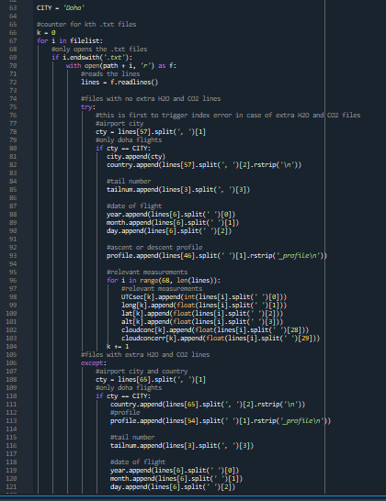

**Saturday 19/12/2020**

-Doha only flight profiles code

-compare summer and winter data

